Name: | ___________________________________________________ |  |  |  | Date: ___________
 | Subject - Year 8 Mathematics  Investigation 1, 2013  Topic – Perimeter & Area  Take home component
Date out: |  | Week ____ Date _____________ | Date Due: | Week ____ Date _____________
Take home component weighting: |  | 0% of the year | In-class component weighting: | 5% of the year.
AIM: In this assessment, you will be investigating area and perimeter for simple and compound shapes.
There are two parts to this assessment:
Item | Purpose | Marks available
Take-Home | To expand your knowledge and skill with Perimeter and Area. | None
In-Class | To test your knowledge and skill with Perimeter and Area. | **% of year

This Take-Home part is to be completed at home and you have one week to complete it. You will not be permitted to do this part in class. If you need help there are after-school maths classes where you can obtain help.

While completing this part, you should produce one A4 sheet of notes (front and back), which you will be allowed to use in the In-Class Verification. There will also be bonus marks for those producing a suitable sheet of notes.

You will not be permitted to use your Take-Home part in the In-Class.

SECTION A: PERIMETER
 |  | VOCABULARY
Perimeter
The distance around any two-dimensional shape, such as a rectangle or a circle.
Circumference
The distance around a circle or the perimeter of the circle.
Radius
The distance from the centre of a circle to its circumference.
Diameter
The width of a circle, measured through its centre.
PI or
A number used in calculations involving circles. It is the number of times the radius goes round the perimeter of a circle. PI is approximately 3.14.

UNITS
Perimeter, circumference, radius and diameter are all measured in units of length e.g.
metres, cm, mm, km etc.
1. | Perimeter of a rectangle
 | The perimeter of a straight-sided shape is equal to the total of all the sides.
 | Example: |  | Now your turn
 | A room has a length of 5m and a width of 4 m.  The perimeter will be 4m + 5m + 4m + 5m = 18m  Note:  If the shape is a rectangle you can add the length and width and double the result |  | Calculate the length of the perimeter of a carpet with length 2.5m and width 1.8m  Answer on back page
2 | Perimeter of a circle
 | The length of the perimeter of a circle (also known as the circumference of the circle) is equal to the diameter of the circle multiplied by PI.
 | Example |  | Now your turn:
 | A circle has a diameter of 12m.  The length of the perimeter is 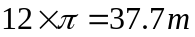 |  | - Calculate the length of the perimeter of a circle of diameter 3.2m  - Calculate the length of the perimeter for a wheel with a radius of 0.4m  Answers on back page

SECTION B: AREA OF SIMPLE SHAPES

VOCABULARY
Area
The amount of space within a two-dimensional shape.
Right Angle
An angle of 90 degrees.
Right Angled Triangle
A triangle with a right angle as one of its angles (the largest).
UNITS
Area is measured in square units e.g. square metres (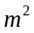), square centimetres (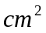), square millimetres (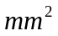) etc.

3. | Area of a rectangle by counting squares
 | If an area has a square or rectangular grid, you can calculate the area by counting the number of squares or rectangles and multiplying by the area of one of them. (This is very useful when you are working out the area of pavers or tiles).
 | Example | Now your turn:
 | Each of the tiles has an area of 0.2 square metres.  The total area of the tiles is 0.2 x 30 = 6 | Calculate the area covered by 100 tiles each having an area of 0.1  Answer on back page

4. | Area of a square by squaring
 | The area of a square shape is simply the length of a side (all are the same) and multiply it by itself. (In Algebra we call this squaring and it looks like this 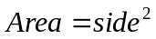)
 | Example | Now your turn:
 | 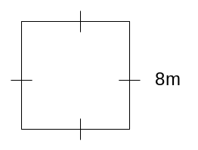  Area = 8 x 8 = 64 | Calculate the area of a square rug of side 2.4m  Answer on back page

5. | Area of a rectangle by multiplication
 | The area of a rectangular shape is the length of one side multiplied by the other side.
 | Example | Now your turn:
 | 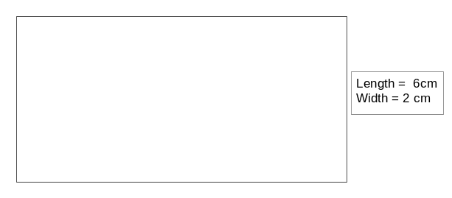  Area = Length x Width = 6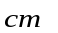x 2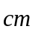 = 12 | A lawn is 12m long and 7m wide. Calculate its area:  Answer on back page
6. | Area of a circle
 | The area of a circle is PI multiplied by the radius squared.
 | Example | Now your turn:
 | 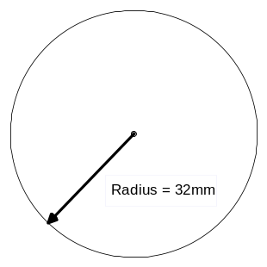  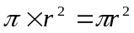  note:  In the example r is the radius and so the area is (we normally do not write the ) | 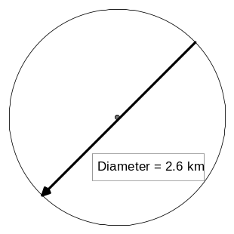  Answer on back page

7. | Area of a triangle
 | The area of a triangle is equal to half the length of the base multiplied by the perpendicular height. In a right-angled triangle multiply the two shortest sides together and half the answer.
 | Example 1 | Example 2
 | 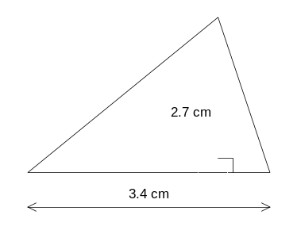  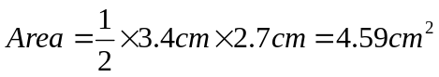 | 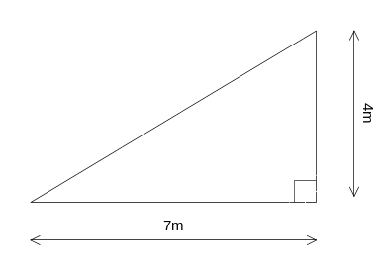  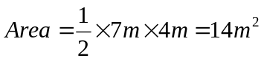
Now your turn:
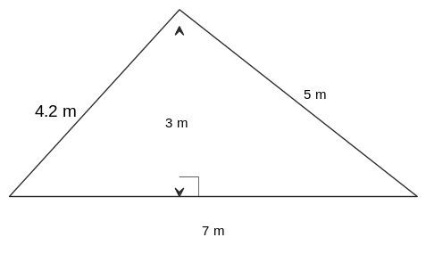Answer on back page

SECTION C: AREA OF COMPOSITE SHAPES
VOCABULARY
Simple shapes
Shapes such as square, circle, rectangle, triangle etc.
Composite shapes
Shapes which are made from two or more simple shapes by adding on or cutting out eg ring, t shape

To find that area of a composite shape:
- Divide them into simple shapes
- Calculate the areas of the simple shapes and then
- Add or subtract them to find the area of the composite.

8. | Rectangle with rectangle added
The shape below is a rectangle with a rectangle added on the end.
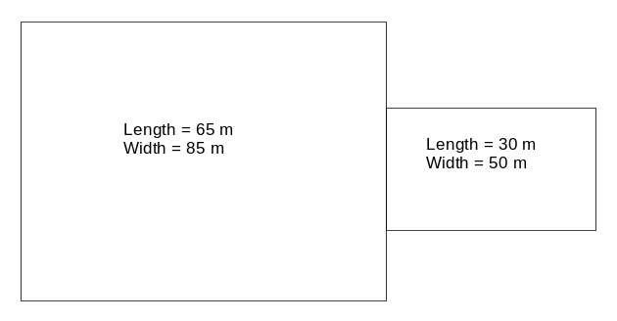
The area of the composite is the area of one rectangle plus the area of the other rectangle.
- Calculate area of one rectangle
- Calculate area of other rectangle
c) Add the two areas together

9. | Rectangle with rectangle removed
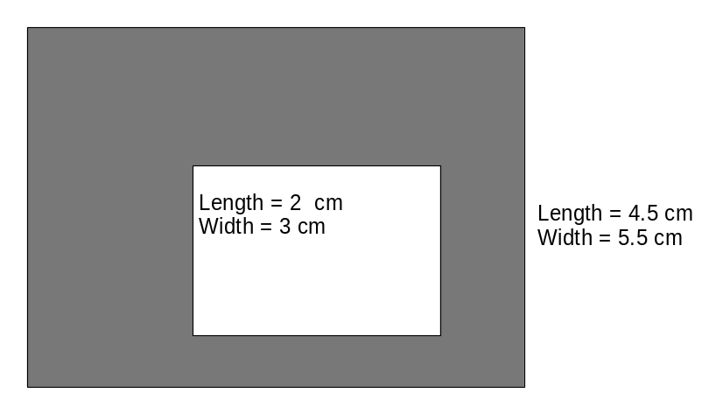
The area of the composite shape represented by the shaded region is the area of the large rectangle minus the area of the smaller rectangle.
- Calculate area of large rectangle

- Calculate area of the small rectangle

c) Subtract the area of the small rectangle from the area of the large rectangle.
Answers on back page

10. | Rectangle with circle removed
The shape below is a rectangle with a circle removed.
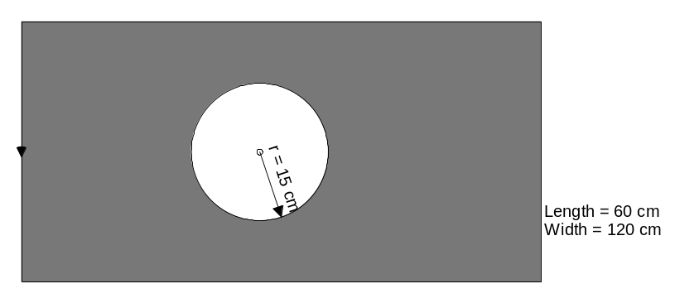
The area of the composite shape represented by the shaded region is the area of the rectangle minus the area of the circle.
- Calculate are of the rectangle

- Calculate area of the circle

- Subtract the area of the circle from the area of the square

 | Answers
 | 1. 8.6 m  2. a)10.05 m b)2.51 m  3. 10 m²  4. 5.76 m²  5. 84 m²  6. 5.31 m²  7 10.5 m²  8. a) 5525 b) 1500 c) 7025 | 9.  a) 24.75  b) 6.00  c) 18.75 | 10.  - Calculate are of the rectangle: 60 cm x 120 cm= 7200  - Calculate area of the circle: 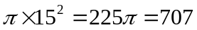  - Subtract the area of the circle from the area of the square: 7200 - 707 = 6493

